Image | 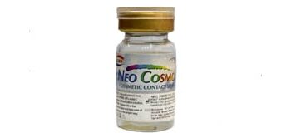
Brand | DIOR
Model Name | NEO COSMO
Price | RS 3000
PRODUCT DETAILS

